**Create a Spring Web Project using Maven**   
Run the SpringLearnApplication class.

**SME to walk through the following aspects related to the project created:**

1. src/main/java - Folder with application code
2. src/main/resources - Folder for application configuration
3. src/test/java - Folder with code for testing the application
4. SpringLearnApplication.java - Walkthrough the main() method.
5. Purpose of @SpringBootApplication annotation
6. pom.xml
   1. Walkthrough all the configuration defined in XML file
   2. Open 'Dependency Hierarchy' and show the dependency tree.

**Folder with application code.**

**SpringLearnApplication class:**

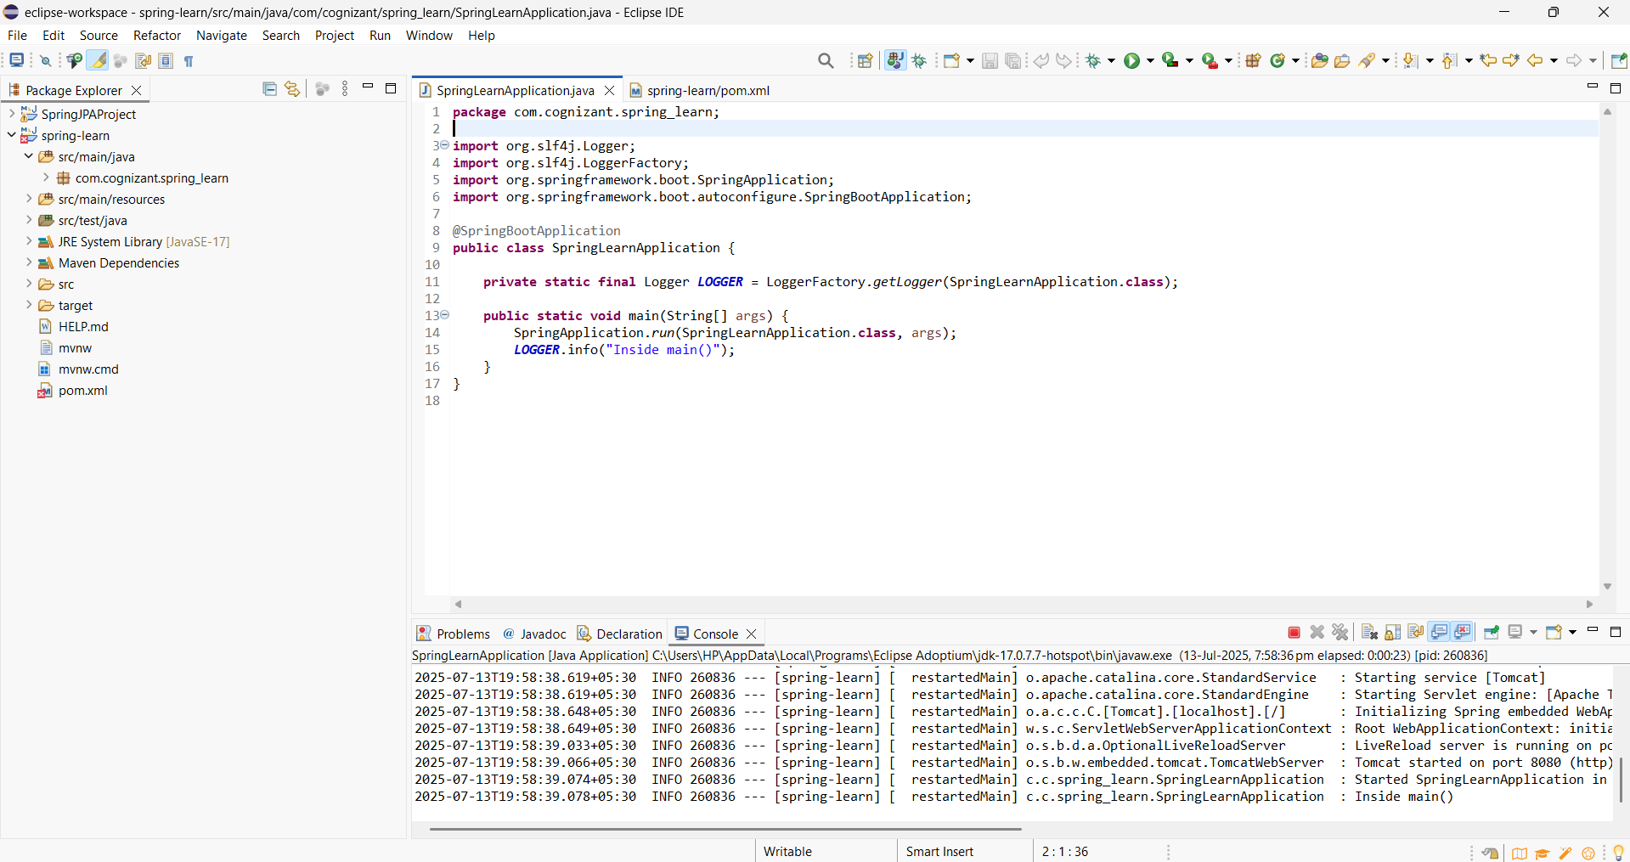

**Pom.xml:**

